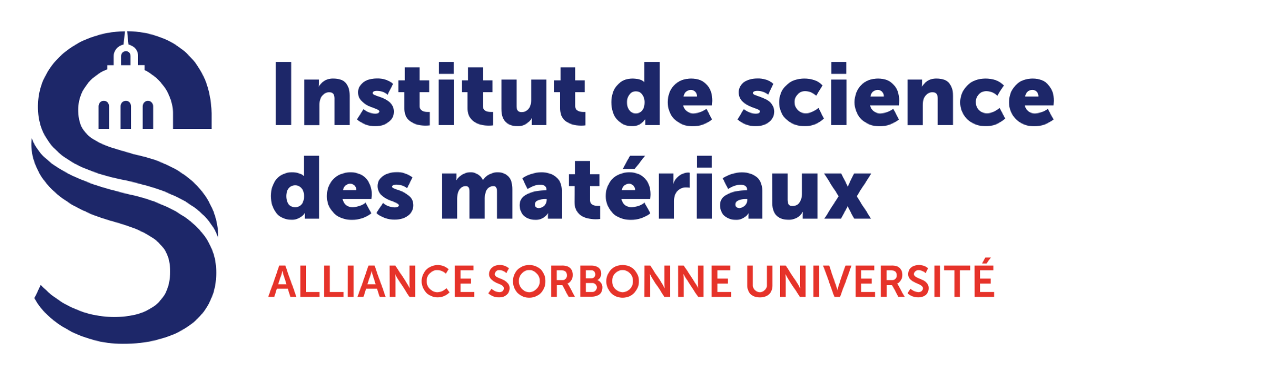

AAP 2022 iMAT - Scientific application form

FAQ : https://materiaux.sorbonne-universite.fr/la-recherche/les-appels-projets/faq-et-conseils-pour-deposer-un-dossier-de-candidature
The project should be written in English as it will be read by members of IMAT’s international strategic committee. It should consist of:
- Scientific context of project (max. 1,5 pages)
  - Aim, Context, Scientific approach, Risks, Bibliography. Figures are welcome.
  - Skills and coherence of team
- Research plan with provisional calendar (max. 0,5 page)
- Research CV of PI and co-PI’s (max. 1 page)
  - Link to publication list
  - Research domain and skills
  - Grants and theses in course.

